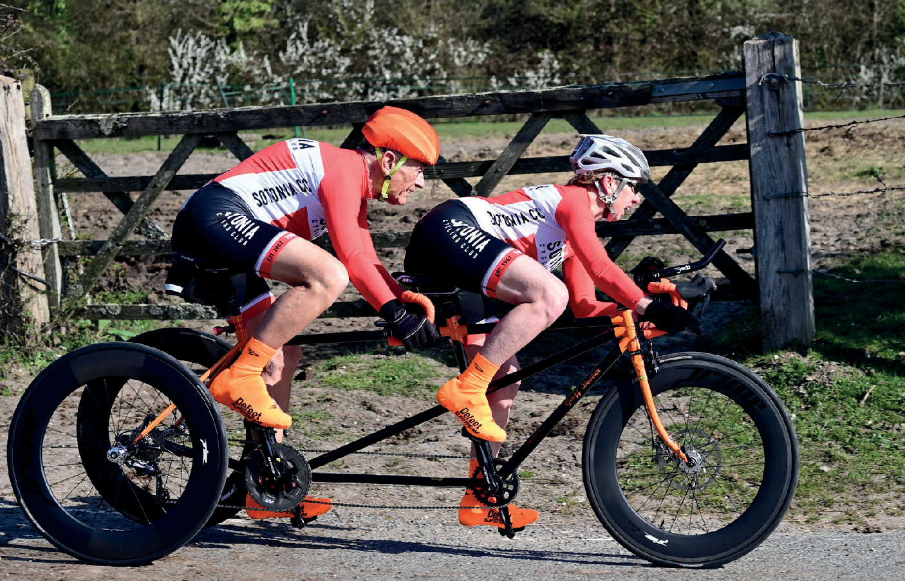

Open 10 Mile Time Trial
Incorporating Wessex VTTA
10 Mile Championship
Results
Sunday 10th July 2022 | Course P612/10
Promoted for and on behalf of Cycling Time Trials under their Rules and Regulations

Timekeepers: Mary Corbett, Norman Harvey, Sotonia CC
Claire Newman, Crabwood CC
Organiser: Graham Harman 16 Woodman Close, Sparsholt, Winchester, Hants, SO21 2NT
Marshals: Stuart Martingale, Wout Davidse
Refreshments: Carron Harman

Thank you to all the time keepers and marshals for getting up early on a Sunday morning.
Thank you to everyone that entered and rode on what turned out to be a lovely day on a fast course.
Congratulations to all the prize winners and to everyone who set a new PB also to those that were pleased with their time.
If you are a prize winner please send me your details and I shall issue your prize.
Many Thanks

Prizes
Male: 1st Jonathan Dorwood 18.37 £20
2nd Matthew Buckley 19.02 £15
3rd Bobby Buenfeld 19.47 £10
3rd Kevin Baker 19.47 £10
Female: 1st Kirsty McSeveney 22.06 £20
2nd Rebecca Pearce 24.04 £15
Juvenile: 1st Bobby Buenfeld 19.47 £20
Vets on STD: 1st Nigel Pratt +6.51 £20
2nd Jake Prior +6.33 £15
3rd Kirsty McSeveney +6.32 £10

Fastest Team of 3: Velo Club St.Raphael £10 each
Matthew Buckley, Kevin Baker, Nigel Pratt
Wessex VTTA 10 mile Championship Results
1st Kirsty McSeveney +6.32
2nd Adrian Talley +6.21
3rd Kevin Baker +6.19
Results

Firstname | Lastname | Club | Gender | Cat | Age | Time | STD
1 Jonathan | Dorwood | Army CC | M | E | 22 | 18.37
2 Matthew | Buckley | Velo Club St Raphael | M | S | 30 | 19.02
3  Bobby | Buenfeld | Velo Club Venta | M | J | 15 | 19.47
4  Kevin | Baker | Velo Club St Raphael Wessex | M | V | 40 | 19.47 | 6.19
5  Nigel | Pratt | Velo Club St Raphael | M | V | 50 | 20 | 6.51
6  Simon | Berogna | Velo Club St Raphael | M | V | 48 | 20.15 | 6.26
7  Adrian | Talley | Portsmouth North End CC. Wessex | M | V | 49 | 20.25 | 6.21
8  Craig | Russell | Andover Wheelers | M | V | 51 | 20.3 | 6.26
9  Richard | Bradley | 3C Cycle Club | M | V | 48 | 21.09 | 5.32
10  Jake | Prior | Velo Club St Raphael | M | V | 59 | 21.11 | 6.33
11  Kirsty | McSeveney | …a3crg Wessex | F | V | 41 | 22.06 | 6.32
12  Ian | Knight | Andover Wheelers | M | V | 53 | 22.16 | 4.51
13  Peter | Perin | Bournemouth Arrow CC. Wessex | M | V | 55 | 22.24 | 4.54
14  Michael | Harrison | North Hampsire RC | M | V | 47 | 22.5 | 3.46
14  Gary | Chiverton | Bournemouth Jubilee Wheelers Wessex | M | V | 61 | 23.09 | 4.49
15  Stuart | Thompson | Velo Club St Raphael | M | V | 47 | 23.12 | 3.24
16  Michael | Banfeild | DHC | M | V | 64 | 23.22 | 5
17  David | Phillips | New Forest CC Wessex | M | V | 67 | 23.22 | 5.27
18  David | Welling | Farnham RC Wessex | M | V | 68 | 23.4 | 5.18
19  Mark | Lisk | 3C Cycle Club | M | V | 49 | 23.41 | 3.05
20  Stewart | Harrison | Kings Lynn CC | M | V | 55 | 23.45 | 3.33
21  Alistair | Cooper | Sotonia CC | M | V | 42 | 23.46 | 2.28
22  Stephen | Skinner | Velo Club St Raphael | M | V | 66 | 23.48 | 4.51
23  Jonathan | Legg | Sotonia CC | M | V | 46 | 24.02 | 2.3
24  Rebecca | Pearce | Ridgeway Riders | F | V | 52 | 24.24 | 5.11
25  Mike | Boyce | …a3crg Wessex | M | V | 66 | 24.46 | 3.53
26  Peter | Iffland | Chippenham & District Wheelers | M | V | 58 | 24.58 | 2.39
27  Robert | Jolliffe | New Forest CC Wessex | M | V | 69 | 25.56 | 3.12
28  Dave | England | Crabwood CC W | M | V | 79 | 26.32 | 4.5
29  Chris | Summers | Sotonia CC Wessex | M | V | 70 | 26.41 | 2.38
30  Pete | Wilson | Bournemouth Arrow CC W | M | V | 69 | 55.23 | -27.15
Mark | Wheeler | 3C Cycle Club | M | V | 61 | DNS(A)
Dave | Dent | GS Stella | M | V | 58 | DNS(A)
William | Simmons | Christchurch Bicycle Club Wessex | M | V | 70 | DNS(A)
David | West | Salisbury Road & Mountain CC | M | V | 52 | DNS(A)
Darren | Lyons | Army CC | M | V | 36 | DNS(A)
Tim | Cooke | Sotonia CC | M | V | 54 | DNS(A)
Simon | Hall | Crabwood CC | M | V | 52 | DNS(A)
Jo | Bissett | Andover Wheelers | M | V | 43 | DNS(A)

